**Thesis outline:**

**Abstract:** Need of the thesis, goal, hypothesis, results, Interpretation (future things??)

**Introduction:**

Introduction to problem,

Some background,

Recent works, comparison of works,

Knowledge gap,

Methods which is similar but why can’t be applied here

**Data:**

Source, what it contains, see it in C:\Users\Smit3\Downloads\Mesoscale-Activity-Analysis2\Report\version3.pdf

Maybe try to get more metadata about

**Data Engineering:**

Data curation part, all the operation and all functional operations done on the data

**Data cleaning:**

see it in C:\Users\Smit3\Downloads\Mesoscale-Activity-Analysis2\Report\version3.pdf

maybe include queries, like good bad trials, CCF overlaps.

**Data Processing:**

**Methodology:**

**Firing Rate:**

**Spike statistics:**

**Dimentionality reduction:**

**Coding direction**

**PCA**

**Multimodal analysis:**

**CCG:**

**Autocorrelograms:**

**Tau,intrinsic timescale:** Diminishing Value,

**Jitter:**

**Fluorescence Analysis:**

**CCF-CCG:** Hypothesis,

**p-value:** Statistical Methods, CCG peak, Coincidence, there are other kind of simulation test in C:\Users\Smit3\Downloads\Mesoscale-Activity-Analysis2\Literature\Thesis\amarasingham-et-al-2012-conditional-modeling-and-the-jitter-method-of-spike-resampling.pdf

**Content**

**Abstract**

from C:\Users\Smit3\Downloads\Mesoscale-Activity-Analysis2\Report\version3.pdf

and new conclusion and methods according to recently done work.

**Introduction**

from C:\Users\Smit3\Downloads\Mesoscale-Activity-Analysis2\Report\version3.pdf

and rest of the introduction and Related work are In the Conversation of “SMIT THESIS”

Need to Do more Literature review >15papers

**Related work/Background (knowledge gap, Contribution)**

**Data**

* **Data acquisition/Source/availability/Dataset/Experiment Settings**

Starting and bit from C:\Users\Smit3\Downloads\Mesoscale-Activity-Analysis2\Report\version3.pdf

And other following bits are from Chen et al.C:\Users\Smit3\Downloads\Mesoscale-Activity-Analysis2\Literature\Chenmultiregional.pdf

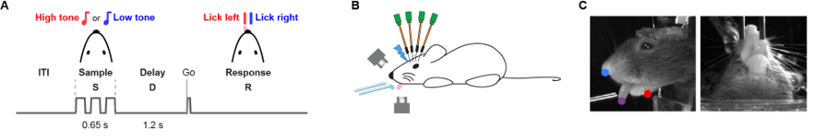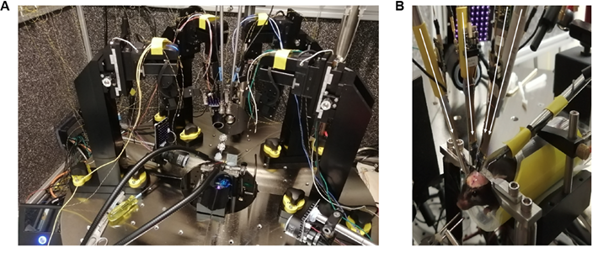

**Animals and surger**y

This study is based on data from 28 mice (Table 1), including twenty five VGAT-ChR2 EYFP (Jackson laboratory, JAX #014548), one C57BL/6J (JAX #000664), one Sst IRES-Cre (JAX #013044) crossed with reporter mouse Ai32 (Rosa26-LSL-ChR2-EYFP, JAX #012569), and one Emx1-Cre (JAX #005628) crossed with R26-LNL-GtACR1 Fred-Kv2.1 reporter mouse (JAX #033089). See Table 2 for recordings made in each mouse. All procedures were in accordance with protocols approved by the Janelia Research Campus Institutional Animal Care and Use Committee. Detailed information on water restriction has been published (Guo et al. 2014). Mice were housed in a 12:12 reverse light:dark cycle and performed behavioral tasks during the dark phase. Behavioral sessions lasted 1 to 2 h where mice received all their water (range, 0.3 to 1.5 mL). All surgical procedures were carried out aseptically. Mice were implanted with a titanium headpost and single housed. Recording well and craniotomy preparation for electrophysiology in head-restrained awake mice have been described in detail (dx.doi.org/10.17504/protocols.io.9a8h2hw). Buprenorphine (0.1 mg/kg, IP injection) was used for postoperative analgesia and Ketoprofen (5mg/kg, subcutaneous injection) 40 The copyright holder for this preprint bioRxiv preprint doi: https://doi.org/10.1101/2023.03.01.530520 ; this version posted March 2, 2023. (which was not certified by peer review) is the author/funder, who has granted bioRxiv a license to display the preprint in perpetuity. It is made available under a CC-BY-NC-ND 4.0 International license . was used at the time of surgery and postoperatively for two days. After head post implantation, all mice were allowed to recover for at least 3 days with free access to water before the start of water restriction. Craniotomies for recording were made after behavioral training.

**Behavior and video tracking**

Mice performed an auditory delayed response task (Figure 1A) (Inagaki et al. 2018). The instruction stimuli during the sample epoch were pure tones played at one of two frequencies (3 kHz or 12 kHz). Each tone was played three times for 150 ms with 100 ms inter-tone intervals. The sample epoch was followed by a 1.2 s delay epoch. An auditory ‘Go’ cue (carrier frequency of 6 kHz with 360 Hz modulating frequency, 0.1 s duration) indicated the end of the delay epoch. Licking early during the sample/delay epoch triggered a replay of the epoch. During the response epoch (answer period: 1.5 s) mice reported the instruction by licking one of the two lick ports. Licking (consumption period: 1.5 s) the correct lick port triggered a small water reward (0.1 ~ 0.2 ul). Licking the incorrect lick port triggered a timeout (1-3 s). After mice stopped licking for 1.5 s, the trial ended, followed by a 250 ms inter-trial-interval. Early lick trials and no response trials were excluded for analysis. Overall performance was computed as the fraction of correct control trials (i.e. no photostimulation), excluding any early lick trials. We selected experimental sessions for analysis based on following criteria: overall behavioral performance (> 65%), and at least 50 correct lick left and lick right trials each. Two CMOS cameras (CM3-U3-13Y3M, FLIR) were used to track orofacial movements of the mouse under IR light illumination (940 nm LED). The cameras were equipped with 4-12 mm focal length lenses (12VM412ASIR, Tamron) and a pixel resolution of 71 µm. High-speed videos from a side view and a bottom view (Figure 1C) were acquired at 300 Hz using software FlyCapture (TELEDYNE FLIR). We trained DeepLabCut (Mathis et al. 2018) to track the movement of tongue, jaw and nose (Figure 1I).

**Multi-regional electrophysiological recordings**

We designed a flexible manipulator system for multiple Neuropixels probe insertions (https://www.janelia.org/open-science/manipulator-system-for-multiple-neuropixels probe-recordings). Three to four small craniotomies (diameter, 1 ~ 1.5 mm) were made over target brain areas one day before the first recording session. Details of recordings made with multiple Neuropixels probes in head-restrained behaving animals have been published (dx.doi.org/10.17504/protocols.io.8tphwmn). Target regions, insertions angles, probe types, etc are summarized in Table 2. All coordinates are given with respect to Bregma (AP, anterior-posterior; ML, medial-lateral; DV, dorsal-ventral). Extracellular spikes were recorded using Neuropixels 1.0 probes, 2.0 single-shank probes, and 2.0 multi-shank probes (J. J. Jun 2017; Steinmetz et al. 2021) (Table 2). Three to seven recordings were made from each craniotomy. Recording depth was inferred from manipulator readings (Sensapax uMp manipulators). After completion of probe insertion, brain tissue was allowed to settle for several minutes before recording. During recordings the craniotomies were immersed in saline. Probes were configured and data were visualized and streamed to disk using the open source software package SpikeGLX (https://billkarsh.github.io/SpikeGLX/). Data from up to five simultaneously recorded probes were acquired at 30 kHz. Sync waves (0.5 s duty cycle TTL pulses) were recorded across probes and on auxiliary channels for synchronization.

* **Data Processing/Curating/Cleaning**

**From** C:\Users\Smit3\Downloads\Mesoscale-Activity-Analysis2\Report\version3.pdf

But add the actual names of techniques like

For Data org/acq : File handling : pynwb and h5py, DANDI API CLI(Mostly in above subsection),

Data Transformation: Defining/segmenting in epochs, Spike binning (kernel smoothing)

**Consistent Referencing**: Ensure consistent referencing for each neural unit, electrode, and anatomical region. Keeping track of these references across sessions is important for multi-region analyses. This can be facilitated by assigning unique identifiers to electrodes and neurons and using metadata files or lookup tables.

**Anatomical Filtering**: Focus on data from specific brain regions, such as ALM and Thalamus, by filtering units or channels based on their anatomical metadata. This is typically specified in tables or metadata files in the NWB dataset

**Temporal Alignment:** Align the start and end times of each epoch (e.g., stimulus, delay, and go) to ensure temporal consistency. Any session where epochs are not sequential or contain time gaps should be flagged for potential removal or correction.

**Trial Exclusion Criteria**: Trials with abnormal durations (outliers) or where epoch timings are inconsistent (e.g., delay periods lasting outside of the expected 1–1.3 seconds) should be excluded. Establishing a maximum trial duration (e.g., 5.3 seconds in our case) helps maintain uniformity in trial analysis.

**Epoch Outliers**: distribution of duration(check very high/low duration nd remove them)

**Spike Outliers:** Spike with low firing rate

Additional Queries as per Requirements and further analysis??

GPT SUGGESTED INFO: (REQUIRED?????)

**Metadata Documentation**

* **Detailed Metadata**: Document all preprocessing steps and session-level details (e.g., electrode coordinates, anatomical labels, session timestamps). This metadata is essential for reproducibility and for multi-region analyses that require consistency across sessions and subjects.

**Automated Checks**:

Implement automated checks to verify key data characteristics after each processing step, such as trial durations, firing rate distributions, and epoch alignment. These checks can flag abnormalities early, ensuring that only high-quality data progresses through the analysis pipeline.

• **Manual Review**: Visualize key data characteristics (e.g., spike rasters, firing rate histograms, epoch distributions) to manually spot-check for any anomalies that automated checks might miss. Reviewing a subset of trials per subject can also help confirm that processing steps are being consistently applied.(THIS IS SOMETHING I DID)

By rigorously applying these methods, you’ll be able to maintain high data quality, ensuring that your subsequent analyses are both reliable and interpretable.

**Methodology/Data Analysis:**

* **Preprocessing:**

**Firing Rate and Kernel smoothing**:

Spike Statistics:

Other functions/Methods/Techniques???

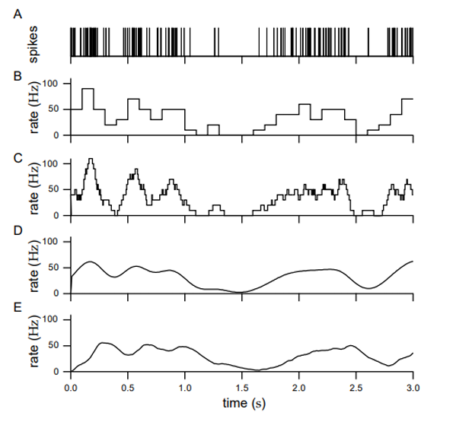

**Dimensionality Reduction** for Complex structure

Coding Direction and PCA ( Encoding/ Decoding of patterns (the exact detailed explanation in Internship form in gwdg email)

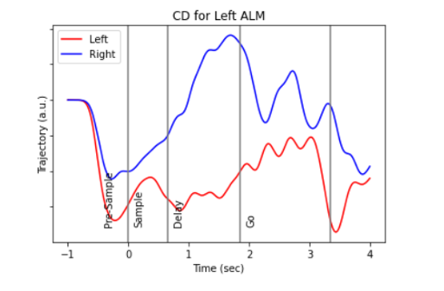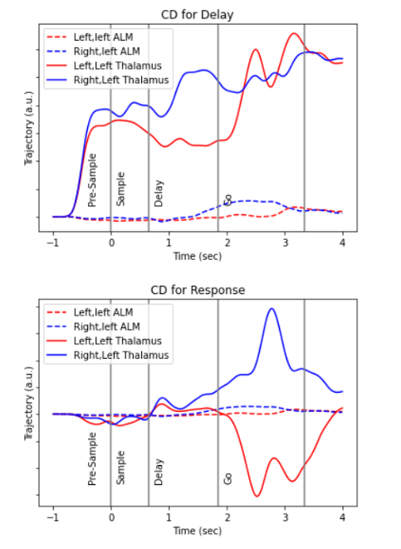

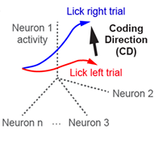 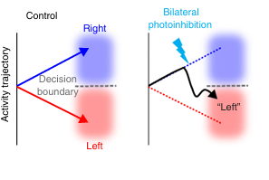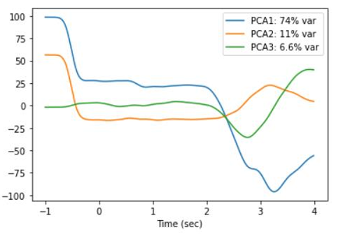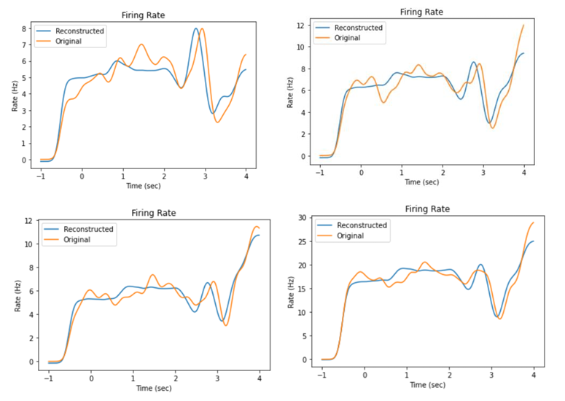

(Factor Analysis??)

* **Flow of the Pipeline/architecture/work flow:**

Try to come up with some flow chart/Diagram explaining work flow.

**Multimodal Analysis**

* **CCG**
  + **Jitter**
  + **Jitter Corrected**
  + **Peak filtering**
    - **Integrating for area (peakwidth)**
    - **Peak/std >= n-fold**
* **Fluorescence Analysis/Overlap**
  + **Projection Zones** (ALM projection zones for Thalamic neurons_Chen et)
* **CCF-CCG Correlation**
* **Autocorrelograms (State and Answer the hypothesis from sticky notes)**
  + **Tau** (intrinsic time scale and inverse exponential curve fit)
  + **Peaks Criteria**
  + **Positive Tau** (Use Dynamic second peak And Try to fir Tau for this)
  + **Decaying Curves only**
* **P-values** 
  + **Test Statistics:** Spike Coincidence and Jitter CCG peaks(p<=0.05)

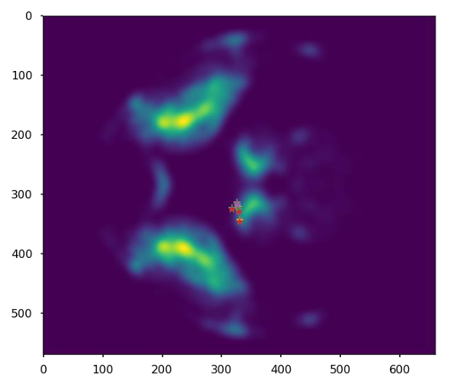

**RE-RUN THE PLOTS WITH PROPER AXIS TITLE**

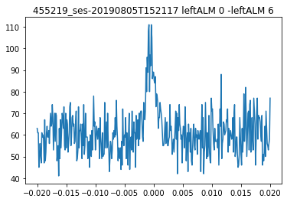

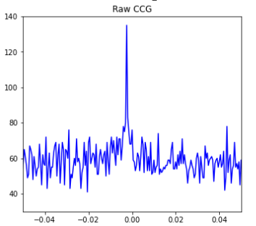

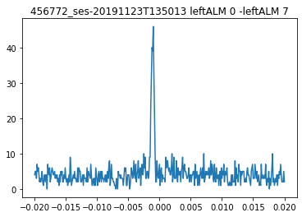

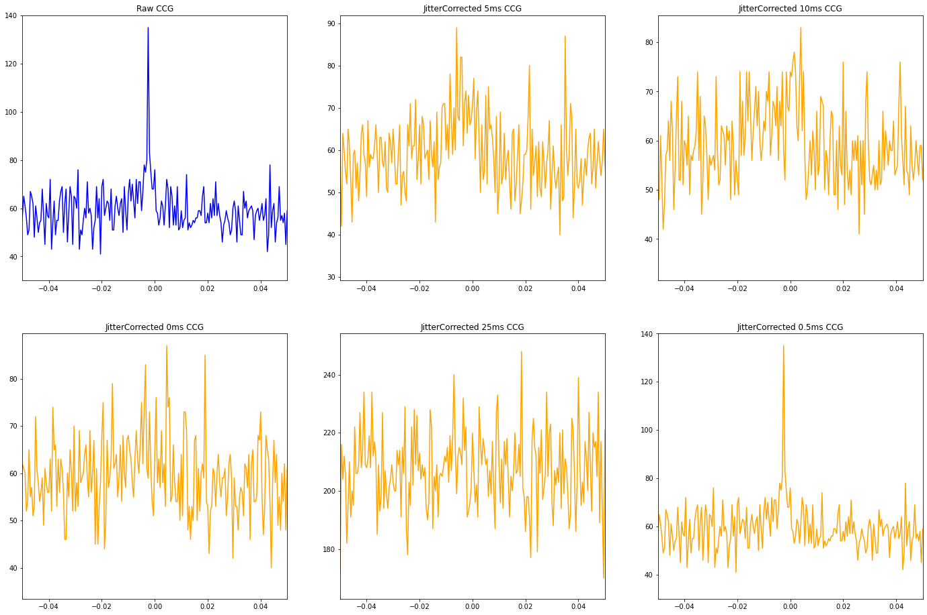

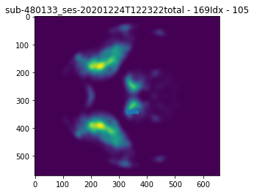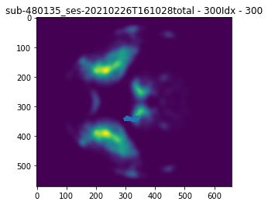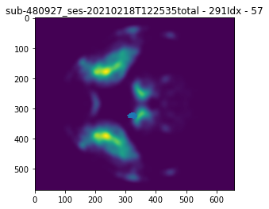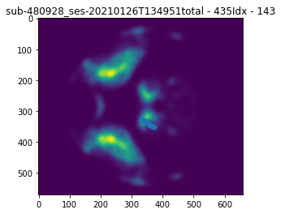

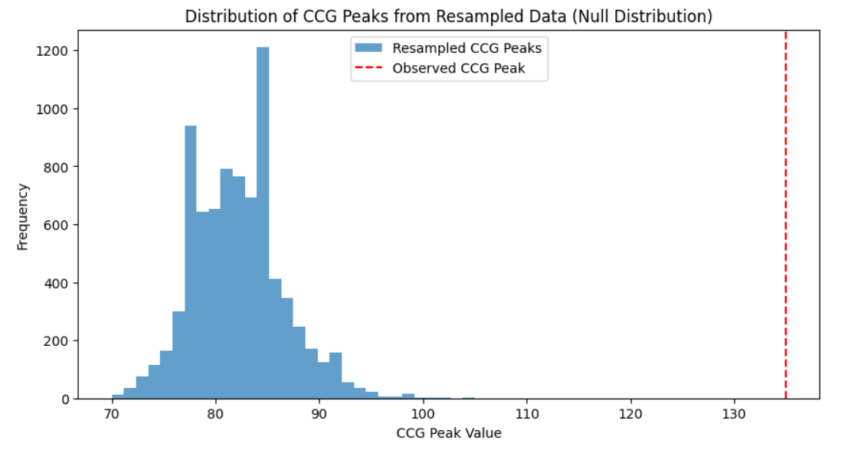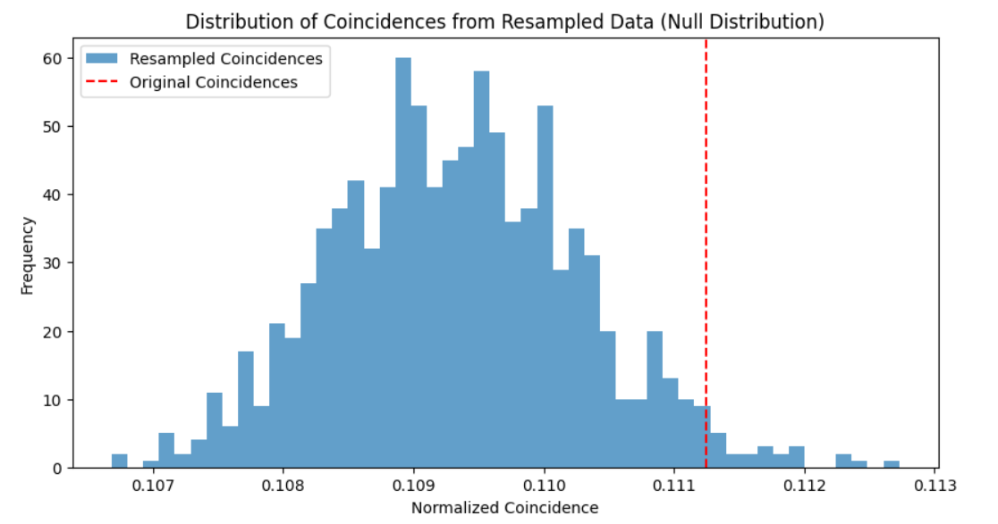

**Results and Discussion:**

Key Findings:

Contribution to Data/Data Analysis/Field

**Future Work/Direction (& Limitation)**

Epoch Analysis

Video Data/Medulla-Tongue movement

Multiregional Loops

>=3 Brain regional Interactions

**Conclusion**

**References**